*Interactive effects of waterlogging and atmospheric* CO2 *concentration on gas exchange, growth and functional traits of Australian riparian tree seedlings*

James R. Lawson*1, Kirstie A. Fryirs2 and Michelle R. Leishman1

1. Department of Biological Sciences, Macquarie University, North Ryde, NSW 2109, Australia
2. Department of Environment and Geography, Macquarie University, North Ryde, NSW 2109, Australia

* Correspondence author. E-mail: [james.lawson@mq.edu.au](mailto:james.lawson@mq.edu.au)

Running head: “Effects of waterlogging and eCO2 on riparian tree seedlings”

ABSTRACT

The ability to survive and thrive in repeatedly waterlogged soils is characteristic of plants adapted to riparian habitats. Rising atmospheric CO2 has the potential to fundamentally alter plant responses to waterlogging by altering gas exchange rates and stoichiometry, modifying growth, and shifting resource-economic trade-offs to favour different ecological strategies. While plant responses to waterlogging and elevated CO2 individually are relatively well characterised, few studies have asked how the effects of waterlogging might be mediated by atmospheric CO2 concentration.

We investigated interactive effects of elevated (550 ppm) atmospheric CO2 and waterlogging on gas exchange, biomass accumulation and allocation, and functional traits for juveniles of three woody riparian tree species. In particular, we were interested in whether elevated CO2 mitigated growth reduction under waterlogging, and whether this response was sustained following a refractory ‘recovery’ period during which soils were re-aerated.

We found species-specific effects of atmospheric CO2 concentration and waterlogging status on growth, gas exchange and functional traits between species, and no evidence for a general effect of elevated CO2 in mediating plant responses to flooding. For one species, *Casuarina cunninghamiana*, elevated CO2 substantially increased growth, but this effect was entirely removed by waterlogging and there was no recovery following a refractory period.

Differential responses to combined waterlogging and elevated CO2 among species may result in compositional changes to riparian plant communities and associated changes in ecosystem functioning.

*Keywords*

Climate change, elevated CO2, waterlogging, flooding, plant functional traits, riparian

INTRODUCTION

Woody plants play an important role in determining the physical structure of many riparian ecosystems (Gurnell et al. 2012), and understanding the responses of woody riparian plants to environmental stresses is central to river rehabilitation and riparian conservation efforts. Riparian plant communities are often dominated by keystone species, and responses of such species to environmental change may have important consequences for riparian landscapes defined by their presence. Changing climatic conditions over the next century are expected to cause shifts in hydrological patterns (Stocker et al. 2013), with changes to the prevalence and intensity of extreme flooding events predicted for many regions (Hennessy et al. 2008). Atmospheric CO2 has also risen substantially over the past century, and a doubling of pre-industrial levels by 2100 is projected (IPCC, 2013). Flooding is already a dominant abiotic stress and an important determinant of ecological strategy for woody riparian plants (Blom and Voesenek 1996; Lawson et al. 2015), but while a significant body of research describes the effects of elevated CO2 on plants at multiple scales, little is known about how the effects of flooding might be mediated by atmospheric CO2 concentration.

To thrive near stream channels, plants must navigate a trade-off between ease of access to water and stresses associated with waterlogging or inundation (Naiman et al. 1993; Colmer and Voesenek 2009). Woody colonists of inset channel features such as bars and benches may experience repeated cycles of soil waterlogging (Corenblit et al. 2009), restricting root access to oxygen (Voesenek and Bailey-Serres 2015). Maintaining root respiration in low O2 conditions requires switching to costly anaerobic metabolic pathways (Drew 1997). The resulting reduction in respiration weakens root function, impairing uptake of water and nutrients (Piedade et al. 2010; Voesenek and Bailey-Serres 2015) and inducing suberisation (Steudle 2000). Stomatal closure may also take place following waterlogging, reducing available CO2 for photosynthesis (Kozlowski 1984; Else et al. 2009). Root-zone hypoxia damages roots by disrupting aerobic respiration and causing an “energy crisis” (Colmer and Voesenek 2009); reactive oxygen species (ROS) then form as bi-products of anaerobic metabolism (Santosa et al. 2007), and subsequent re-aeration further increases ROS production (Steffens et al. 2013). Production of toxic ions by microbes under anoxic soil conditions causes additional stress to roots (Blom and Voesenek 1996). Waterlogging may also impair rhizomicrobial nodule formation and activity, resulting in reduced nutrient uptake (Dawson et al. 1989; Shimono et al. 2012). The degree to which this combination of stressors influences plant growth is ultimately determined by species’ ability to mobilise physiological and morphological responses which mitigate damage (Bailey-Serres and Voesenek 2008).

As with waterlogging, atmospheric CO2 concentration is known to affect plant physiology and growth by altering the fundamental economics of carbon, water and macronutrient uptake and use (Poorter and Navas 2003; Wang et al. 2012; Reich et al. 2014). Individual species responses are variable, but photosynthetic CO2 assimilation in C3 plants tends to increase under elevated CO2 (eCO2)(Curtis 1996). Stomatal conductance is also typically reduced (Ainsworth and Rogers 2007), with attendant gains in water use efficiency (Holtum and Winter 2010; Keenan et al. 2013; van der Sleen et al. 2014). Biomass accumulation in response to eCO2 may be enhanced (Wang et al. 2012), but this depends on the availability of water and macronutrients (Körner 2006; Manea and Leishman 2014; Reich et al. 2014). Increased allocation of biomass to roots occurs under eCO2 (Nie et al. 2013) and this effect is interactive with environmental stresses such as drought or low soil fertility (Wang and Taub 2010). Increased rates of production and turnover of fine roots under eCO2 have been shown in the field, which has important implications for nutrient cycling and ecosystem functioning (Pregitzer et al. 1995, 2000; Matamala and Schlesinger 2000; Lipson et al. 2014). eCO2 is also known to affect functional traits indicative of positions along economic spectra (*sensu* Reich 2014). Reduction in specific leaf area (SLA) under eCO2 may be linked to accumulation of non-structural carbohydrates in leaves (Poorter and Navas 2003; Bader et al. 2010). Alteration of traits reflecting economic trade-offs is of particular significance at the seedling stage, as functional traits of trees are most strongly adapted to the regeneration niche (Poorter 2007).

Taken individually, waterlogging and elevated atmospheric CO2 concentration appear likely to exert opposing effects on plant growth. The possibility that eCO2 may mitigate growth reduction under waterlogging warrants investigation of the interactive effects of these two important environmental variables. Literature describing interactive effects of atmospheric CO2 concentration and waterlogging or flooding on plant growth is sparse, and findings thus far present an inconsistent picture. eCO2 stimulated biomass production in waterlogged (water table at -10 cm) but not inundated (water table at +5 cm) juveniles of the flood-tolerant tree species *Taxodium distichum* (Megonigal et al. 2005). Increased photosynthesis under eCO2 was not reduced by inundation. This effect was attributed to the increased metabolic cost of maintaining roots under low O2 conditions. In the same study, inundation had no effect on eCO2 stimulation of photosynthesis or biomass production of the aquatic herbaceous species *Orontium aquaticum*. The opposite response was found for a highly flooding tolerant Amazonian tree: waterlogged *Senna reticulata* grown in open top chambers showed greater increment in biomass under eCO2 (Arenque et al. 2014). Similarly, eCO2 was shown to ameliorate the effects of stress due to both salinity and flooding on biomass production in herbaceous saltmarsh plants (Langley et al. 2009). In a follow-up field experiment using open top chambers however, no significant interactions were found between eCO2 concentration and elevation above sea level, which was strongly correlated with proportion of time spent inundated (Langley et al. 2013). Finally, no evidence for an interaction between CO2 concentration and waterlogging status was found on growth or stomatal conductance in soybean (Shimono et al. 2012). To our knowledge, no studies have specifically investigated the effects of eCO2 on recovery from waterlogging. Ability to recover following stress events may be a better indicator of fitness than tolerance of the stress (Gutschick and BassiriRad 2003), and for waterlogged plants, generation of reactive oxygen species following re-aeration is likely to be a significant additional stress (Drew 1997).

FACE and GH experiments are complementary. FACE is best at studying ecosystem processes and community-level functioning, but has limited scope to construct manipulative experiments, and especially to make destructive measurements. GH experiments focused more on individual plants in pots are able to provide data which would not be feasible to obtain using FACE (either bc it is too destructive, manipulations can’t be made, or there isn’t a FACE setup in the system of interest).

The objective of this study was to investigate interactive effects between eCO2 and waterlogging on gas exchange, biomass accumulation and allocation, and functional traits for riparian tree species. In particular, we were interested in whether eCO2 mitigated growth impairment under waterlogging, and whether this response was sustained following a refractory ‘recovery’ period during which soils were re-aerated. We also investigated two hypothesised mechanisms by which such an interactive effect might occur: a.) higher water use efficiency under eCO2 (Holtum and Winter 2010) facilitates photosynthesis in plants with anoxia-impaired root functionality by lowering the water cost of carbon assimilation; b.) eCO2 facilitates biomass recovery by increasing the rate of fine root production during the recovery period (Pregitzer et al. 1995).

STUDY SPECIES & METHODS

We selected three riparian tree species native to south-eastern Australia for this study. *Casuarina cunninghamiana subsp. cunninghamiana* and *Eucalyptus camaldulensis subsp. camaldulensis* dominate many riparian environments in south-eastern Australia; *Acacia floribunda* is also common in this region. Table 1 provides further information on the biology and ecology of these species.

*Experimental Procedure*

We used a fully factorial design comprising two CO2 treatments (ambient and elevated), and three waterlogging treatments (non-waterlogged control, waterlogged and waterlogged then re-aerated for a refractory period), with 8 replicates per treatment combination per species. We measured plant physiology (photosynthetic rate, *A*; stomatal conductance, *Gs*; and instantaneous water use efficiency, *WUE*) as well as biomass, biomass allocation and tissue density traits indicative of ecological strategy and position along economic spectra (Reich et al. 2014).

Plants were grown individually in pots constructed from 90 mm by 700 mm (4.3 L capacity) sections of PVC pipe with drilled endcaps, containing a commercially sourced 80/20 mixture of river sand and soil (Australian Native Landscapes, North Ryde, NSW, Australia). The bottom 2 cm of each pot was filled with gravel (~1 cm particle size) to promote free drainage. 2.5 g L-1 of time-release fertiliser granules (NPK 19.1, 0, 11.9, Yates Australia, Padstow, NSW, Australia) was mixed evenly through the soil medium.

Seeds were obtained from a commercial supplier (Nindethana Seed Service, Albany, WA, Australia) and germinated on moist tissue paper in trays at ~20oC. Following cotyledon emergence, four seedlings were transplanted into each growing pot. Germination was staggered by species to ensure all seedlings were transplanted at the same stage of development (radicle just emerged); all species were transplanted within a 48 hour window. After two weeks of growth, plants were thinned to retain a single, medium sized individual.

Plants were grown in glasshouses at Macquarie University, in Sydney, Australia, between June and November, 2014. Pots were supported by wire mesh on trolleys; pot positioning on trolleys was randomised with respect to species, and trolleys were rotated weekly to offset potential microclimatic effects associated with position within each glasshouse. Two levels of CO2 treatment (380-400 ppm and 530-570 ppm) were used in two replicate glasshouses per level. These CO2 ranges were monitored and maintained using an automated gas delivery system (Canary Company Pty Ltd, Lane Cove, NSW, Australia). The lower range corresponds to the ambient atmospheric CO2 concentration, while the higher range reflects the predicted atmospheric CO2 concentration in 2050 (IPCC, 2013). Temperature was maintained between 16 and 28 oC. Mean air temperatures in the glasshouses ranged between 18 and 22 oC and there were no significant differences between glasshouses in mean, minimum or maximum temperatures. As in previous studies of flooding – CO2 interactions, plants were exposed to ambient light conditions (Megonigal et al. 2005; Shimono et al. 2012; Arenque et al. 2014). Solar exposure ranged between 9 MJ/m2 in June and 22 MJ/m2 in November, with an estimated 40 % of solar radiation being intercepted by the Perspex walls and roof of the glasshouses. Plants were watered by a misting sprinkler system three times daily and provided with supplementary hand watering every 3-4 days to maintain constant soil moisture levels between pots. Trolleys were swapped between replicate glasshouses monthly.

Waterlogging was initiated after 90 days of plant growth and lasted 24 days, in order to simulate a significant flooding event and to allow time for morphological adaptation to manifest. Plants were randomly assigned to “control”, “waterlogged” and “recovery” treatments. “Waterlogged” and “recovery” plants were waterlogged by immersion to within 10 cm of the soil surface in 450 L plastic tubs filled with water. The black tubs were covered with white polythene sheeting to reduce heat absorption. Photosynthetic rate and transpiration rate of plants assigned to the “waterlogged” treatment were measured at the end of the waterlogging period, after which they were harvested. Tubs were drained following the waterlogging period, and “control” and “recovered” treatment plants were grown for a further 23 days before measurement and harvesting.

Photosynthetic rate (CO2 assimilation rate), stomatal conductance and transpiration rate of the newest fully developed leaf were measured for four plants per treatment between 9am and 12:30pm using a Li-Cor 6400XT infrared gas analyser (Li-Cor Inc., Lincoln, NE, USA). Photon flux was set to 1500 µmol m-2 s-1 and temperature was held at 28oC. For leaves which did not completely fill the cuvette, leaf area was measured by digital analysis (ImageJ 1.48 for Windows) of a photograph of the leaf taken against a 2x3 cm2 plastic backdrop, which corresponded to the area of the cuvette. Photosynthetic rate and transpiration rate were determined by correcting values according to the measured area. Instantaneous water use efficiency was calculated as the ratio of CO2 assimilation to transpiration rate.

Upon harvesting, roots were washed free of soil and the plant was separated into fine (<1 mm diameter) and coarse (>1 mm diameter, excluding dead root biomass) roots, and aboveground biomass. Five mature (but not senescing) leaves of each individual were selected for determination of specific leaf area (SLA). Fresh leaf area was determined using a LI-3100C Area Meter (Li-Cor Inc., Lincoln, NE, USA); SLA was calculated as the ratio of fresh area to dry mass. A 5 cm section of stem was cut from 1 cm above the root-stem junction for analysis of stem density. The fresh volume of the stem section was measured using the water displacement method and stem wood density was calculated as the ratio of oven dry mass to green volume. Root dry matter content was used as a proxy for root tissue density (Birouste et al. 2013). Dry matter content of fine roots was calculated as the ratio of oven dry mass to fresh mass. Samples were dried in an oven at 70oC for 72 hours then weighed on a microbalance (Mettler-Toledo, Greifensee, Switzerland). Root mass fraction was calculated as the ratio of root dry biomass to whole plant dry biomass. Stunted plants with a shoot length of < 5 cm were excluded (one individual from each of the following treatments: *A. floribunda*, 390 ppm CO2, “recovered”; *C. cunninghamiana*, 550 ppm CO2, “control”; *E. camaldulensis*, 500 ppm CO2, “control”).

*Data analysis*

All statistical analyses were performed using the R statistical programming environment (R Core Team 2015). We used two-way analysis of variance (ANOVA) to test for main effects of and interactions between waterlogging and CO2 treatments on physiology (photosynthetic rate, stomatal conductance, water use efficiency), biomass (shoot, total root and fine root) and biomass allocation (root mass fraction), and functional traits (fine root dry matter content, stem density, SLA). One observation was omitted as an outlier in analysis of *E. camaldulensis* SLA (390 ppm CO2, “control” treatment) due to substantially higher SLA than conspecifics. Metrics of biomass (total, root biomass, shoot biomass) were compared only between “control” and “recovered” treatment plants, as plants which received the “waterlogged” treatment were 23 days (17 %) younger at harvest.

Post-hoc comparison (Tukey’s HSD) was used to determine which combination of treatments were responsible for interaction effects and waterlogging treatment main effects. Type II sums of squares were used where unbalanced analyses resulted from removal of stunted plants from the study, following Lansgrud (2003). Data were log10 (root mass fraction, SLA) or square root transformed (total root biomass, fine root biomass, shoot biomass) where appropriate to satisfy assumptions of normality inherent in ANOVA. Statistical significance was thresholded at alpha = 0.1 for photosynthetic rate, stomatal conductance and WUE measurements (n = 4) and 0.05 for all other measurements (n = 8).

RESULTS

Descriptive statistics and significance of ANOVA and post-hoc tests are shown for all measurements for each combination of treatments in Table 2.

*Gas exchange and water use efficiency*

Effects of CO2 level and waterlogging on gas exchange were species specific, and although some significant interactions were found between CO2 and waterlogging, we found no evidence that interactive effects were maintained following recovery from waterlogging.

Elevated CO2 significantly increased leaf-level photosynthesis for all three species (*A. floribunda*, p = 0.074, Fig. 1a; *C. cunninghamiana*, p = 0.002, Fig. 1b; *E. camaldulensis*, p = 0.037, Fig. 1c). Photosynthetic rate in *E. camaldulensis* was significantly greater in recovery treatment plants than control plants (p = 0.008). No significant interactions were found between CO2 level and waterlogging status for photosynthetic rate, although waterlogged *A. floribunda* exhibited only a small difference in mean photosynthetic rate between CO2 treatments (20.9 and 22.6 μmol CO2 m⁻² s⁻¹, respectively, Fig. 1a).

CO2 level had no effect on stomatal conductance for any species, and waterlogging status influenced stomatal conductance only in *E. camaldulensis.* Control plants had lower stomatal conductance than waterlogged plants (p = 0.042), and recovering plants (p = 0.0002). Waterlogged *E. camaldulensis* also had lower stomatal conductance than recovering plants (0.059).

Water use efficiency in *A. floribunda* was higher in control than waterlogged (p = 0.002), and higher in control than recovery (p = 0.04), but not waterlogged and recovery plants (Fig. 1g). WUE increased under elevated CO2 as a main effect for *E. camaldulensis* (p = 0.002, Fig. 1h), and interactively with CO2 level for *C. cunninghamiana* (p = 0.063); WUE was higher under eCO2 for waterlogged plants (p = 0.022, Fig. 1i) but not control or recovery plants.

*Biomass production and allocation*

Waterlogging status and CO2 level interacted strongly for one species: eCO2 stimulation of all fractions of biomass production in *C. cunninghamiana* was diminished following recovery from waterlogging.

Total root biomass of plants recovering from waterlogging was lower than control plants for *A. floribunda* (p = 0.028, Fig. 2a). A significant interaction effect was identified for *C. cunninghamiana* (p = 0.049): total root biomass was substantially increased under eCO2 for control (p = 0.011) but not recovery plants (Fig. 2b). Neither CO2 level nor waterlogging had an effect on total root biomass for *E. camaldulensis* (Fig. 2c).

Fine root biomass of *A. floribunda* was lower in recovery plants than control plants (p = 0.005), with no CO2 effect (Fig. 2d). A marginally significant interaction effect was also present for *C. cunninghamiana* fine root biomass (p = 0.076); post-hoc analysis confirmed that control but not recovery plants had significantly greater fine root biomass under eCO2 (p = 0.008) (Fig. 2e). Waterlogging stimulated fine root growth in *E. camaldulensis* (p = 0.046) but CO2 level had no effect (Fig. 2f).

Neither CO2 level nor waterlogging had any effect on shoot biomass for *A. floribunda* (Fig. 2g) or *E. camaldulensis* (Fig. 2i). As with total root biomass and fine root biomass, CO2 level and waterlogging influenced *C. cunninghamiana* biomass interactively (p = 0.009): shoot biomass was higher under eCO2 for control (p = 0.015) but not recovery plants (Fig. 2h).

Root mass fraction (RMF) was decreased by waterlogging for all species, but no significant CO2 or interaction effects were found (Fig. 2j-l). RMF of *A. floribunda* was lower in waterlogged than control plants (p < 0.0001), and lower in waterlogged than recovery plants (p < 0.0001). RMF of *A. floribunda* recovery plants was also lower than control plants (p = 0.016). RMF of both *C. cunninghamiana* and *E. camaldulensis* was lower in waterlogged than control plants (p < 0.0001), and lower in waterlogged than recovery plants (p < 0.0001), but there was no difference between recovery and control plants.

*Functional traits*

We found no evidence to suggest that CO2 mediates functional traits in response to waterlogging status.

Fine root dry matter content (fRDMC) was higher in waterlogged *A. floribunda* than recovery plants (p = 0.027), but not different between control and recovery or control and waterlogged plants. A marginally significant interaction effect was also present for *A. floribunda* (p = 0.067), but no differences were significant upon post-hoc analysis. Waterlogging status also affected *E. camaldulensis* fRDMC (Fig. 3b): control plants had higher fRDMC than waterlogged plants (p = 0.018), and recovery plants (p = 0.053) (marginally significant). eCO2 was associated with significantly increased fRDMC in *C. cunninghamiana* (p = 0.013, Fig. 3c), but waterlogging status had no effect.

Waterlogged *A. floribunda* had lower SLA than control (p = 0.001), and recovery plants (p < 0.0001) (Fig. 3 d). Waterlogged *E. camaldulensis* had higher SLA than control (p = 0.0013) and recovery plants (p = 0.0006) (Fig. 3f). Waterlogging status had no effect on *C. cunninghamiana* SLA (Fig. 3e). CO2 level had no effect on the SLA of any species.

Stem density in *C. cunninghamiana* was increased under elevated CO2 (p = 0.0177) (Fig. 3h), and was lower in waterlogged than control (p = 0.0167) or recovery plants (0.050). Neither CO2 nor waterlogging status had any effect on stem density of *A. floribunda* (Fig. 3g) or *E. camaldulensis* (3i).

DISCUSSION

We found inconsistent effects of atmospheric CO2 concentration and waterlogging status on growth, gas exchange and functional traits between species of riparian tree seedlings and no evidence for a consistent effect of elevated CO2 in mediating plant responses to flooding.

While photosynthesis is the primary means by which plants accumulate biomass, increases in leaf-level photosynthesis may not necessarily translate to biomass gains. Metabolically costly responses to waterlogging tolerance, such as anaerobic catabolism, detoxification of reactive oxygen species and metal ions, and morphological adaptations such as formation of adventitious roots may act as energetic sinks (Colmer and Voesenek 2009). Relationships between photosynthetic rate and biomass responses to waterlogging and CO2 level treatments in this study varied widely between species.

For the three species studied here, only for *C. cunninghamiana* was an interactive effect of CO2 concentration and waterlogging status found. Biomass of shoot, total root and fine root fractions was significantly higher under eCO2 for control *C. cunninghamiana* plants, but not for plants which were recovering from waterlogging, despite increased rates of CO2 assimilation. No significant interaction effect on root mass fraction was found, but visual inspection of the data (Fig. 2k) indicates that eCO2 stimulation of RMF was present in control and recovering, but not waterlogged plants. Re-establishment of pre-waterlogging biomass allocation appears to have occurred despite no differences in total biomass. We found no evidence to support the hypothesis that eCO2 facilitated biomass recovery by increasing the rate of fine root production in *C. cunninghamiana* after waterlogging. Photosynthesis remained higher in recovering plants under eCO2, indicating that their ability to convert the extra photosynthate produced under eCO2 into biomass was impaired by waterlogging.

No increase in any biomass fraction was associated with increased photosynthetic rate under eCO2 for either *A. floribunda* or *E. camaldulensis*. *A. floribunda* underwent substantial root mortality in response to waterlogging, although the presence of spongy white aerenchymous adventitious roots indicated a degree of morphological adaptation to anoxia (Evans 2004). Conversely, waterlogging stimulated fine root growth in *E. camaldulensis*. A proliferation of fine aerenchymous roots both below and above the water line was observed in waterlogged and recovered plants, corresponding to increased fine root mass compared with control plants. The strong morphological response of *E. camaldulensis* root systems combined with higher photosynthetic rate in recovering compared with control plants, and higher stomatal conductance in waterlogged plants than control or recovering plants, indicates that *E. camaldulensis* responded favourably to waterlogging in this study. This growth response concurs with the results of previous studies (Sena-Gomes & Kozlowski 1980; Marcar 1993, although see Kogawara *et al.* 2006). No evidence was found to support the hypothesis that higher water use efficiency under eCO2 might facilitate photosynthesis where waterlogging had caused stomatal closure. WUE was altered by waterlogging only in *A. floribunda*, and by CO2 level only in *E. camaldulensis*. WUE was dependent on the combination of waterlogging status and CO2 level in *C. cunninghamiana*, being higher at eCO2 than aCO2 for waterlogged plants only. The lack of stomatal response to waterlogging indicates that higher WUE under eCO2 is not the mechanism maintaining photosynthetic rate under waterlogging for *C. cunninghamiana*.

Waterlogging and atmospheric CO2 level also altered functional traits in a species-specific manner, but no interactive effects were found. Traits of *A. floribunda* and *E. camaldulensis* were affected by waterlogging status but not CO2 level, whereas *C. cunninghamiana* was affected by CO2. Decreased SLA and increased fine root dry matter content – a proxy for fine root tissue density (Birouste et al. 2013) – in waterlogged *A. floribunda* indicate a shift towards the slower growth – longer lifespan end of their respective economic spectra (Reich 2014), but this shift was not sustained following the refractory period. A corresponding pattern in water use efficiency corroborates this inference. Higher root dry matter content under waterlogging has been linked to the requirement for structural support of air spaces in aerenchymous root tissue (Ryser et al. 2011). Suberization of root hypodermal tissue often occurs under waterlogging as a means of reducing radial oxygen loss (Visser et al. 2000; De Simone et al. 2002) and may also increase root dry matter content. *E. camaldulensis* responded in an opposite manner, with higher SLA under waterlogging, and lower root dry matter content under waterlogging and after the refractory period. This species appears to employ an opportunistic ‘fast growth’ ecological strategy in response to waterlogging, involving proliferation of lower density roots, and lower carbon investment in leaf tissue (Wright et al. 2004; Reich 2014). We found no evidence for decreased SLA under eCO2 as previously described (Poorter and Navas 2003). Previous studies report inconsistent effects of eCO2 on fine root dry matter content in non-riparian species: eCO2 had no effect on *Liquidambar styraciflua or Pinus strobus* fRDMC(Bauer and Berntson 2001; Iversen et al. 2008), caused a small decrease in *Betula alleghaniensis* (Bauer and Berntson 2001) and increased fRDMC in cotton (Prior et al. 1994). In this study, eCO2 significantly increased fine root dry matter content in *C. cunninghamiana* irrespective of waterlogging treatment.

Analysis of gas exchange, biomass accumulation and functional traits after a refractory period provided an opportunity to determine whether responses to waterlogging persisted or were transitory. We were unable to substantiate the hypothesis that eCO2 would increase the rate of biomass recovery from waterlogging by increasing the rate of fine root turnover. *C. cunninghamiana* was the only species for which eCO2 altered biomass accumulation, and suppression of this response to eCO2 was observed following the recovery period. Although we made no analysis of nodulation rates, nodulation of *C. cunninghamiana* by the nitrogen fixing ascomycete *Frankia* is known to be highest under well aerated soil conditions (Dawson et al. 1989). Reduced nitrogen uptake due to nodule mortality or impairment could account for the constrained biomass response to eCO2 post-waterlogging (Reich et al. 2006). While eCO2 did not mitigate growth reduction or mediate changes to functional traits under waterlogging for any species in this glasshouse study, we did observe reduced growth stimulation by eCO2 in one species. This effect was strong, and evident across all measured biomass fractions. Differential responses to eCO2 and waterlogging between species in the field could have important ecological consequences. *C. cunninghamiana* is a highly effective agent of ‘biogeomorphic succession’ in fluvial landscape of south-eastern Australia – that is, it facilitates the creation and stabilisation of fluvial landforms (Erskine and Chalmers 2009). Reduction of eCO2 biomass stimulation by waterlogging could alter spatial patterns of landform stabilisation by *C. cunninghamiana*. Infrequently waterlogged stands on channel banks might be favoured over stands growing on wetter in-channel features such as bars, benches and islands. Differential responses to combined waterlogging and eCO2 between species – notably *C. cunninghamiana* and *A. floribunda*, which frequently coexist – may also result in compositional changes to riparian plant communities and associated changes in ecosystem functioning.

An important concern in making such ecological interpretations from manipulative glasshouse experiments is the extent to which field conditions are properly represented by the experimental design. Replication is an obvious issue: an experiment conducted at a single location at a single time point does not necessarily provide the basis for making general inferences about ecology. Irradiance is likely to be the most important uncontrolled environmental factor influencing the experimental results. Stronger irradiance would likely strengthen the stimulating effect of eCO2 on carbon assimilation, and potentially exacerbate differences in growth rates between plants growing in aerated soil and those with metabolic limitations imposed by waterlogging. As the experiment was conducted primarily over the austral winter and spring (June to November), the effect sizes found here may therefore be reduced compared with summer light conditions.

In the field, riparian plant communities are exposed to cyclical wetting and drying, with compounding effects on component populations. Seedlings are less likely to be exposed to multiple waterlogging events, however, so replicating this aspect of the riparian environment was of minor concern here. Other factors such as constraints by pots on root spread, nutrient supplementation and the lack of interaction between study individuals and other organisms may limit the scope of inference able to be made from this study, however. While open air field setups such as FACE (free air CO2 enrichment) experiments (Norby and Zak 2011) would provide a greater degree of realism, the scale of such approaches typically limits the ability to construct manipulative experiments. Glasshouse experiments focused on individual plants grown in pots are able to provide data which would not be feasible to obtain using free air setups, either because the methods are too destructive, manipulations can not be made, or the extensive funding required to construct infrastructure in the system of interest is not available.

CONCLUSIONS

Waterlogging and atmospheric CO2 concentration both have significant consequences for physiological processes, growth and functional characteristics of riparian tree seedlings. The relative importance of these environmental factors varies according to species, as do the specific effects of each on plants. This study adds to the small but growing body of literature describing the interactive effects of waterlogging and CO2 concentration on woody plants; notably, the outcome for *C. cunninghamiana* concurs with that found for *Taxodium distichum*, a flood tolerant colonist of alluvial riparian areas in the south eastern United States (Megonigal et al. 2005). If it occurs in the field, impairment of eCO2 biomass stimulation in seedlings by waterlogging has the potential to alter demographics and structural dynamics in many Australian riparian communities, especially where *C. cunninghamiana* is a keystone species (Woolfrey and Ladd 2001).

ACKNOWLEDGEMENTS

We would like to acknowledge Urvashi Lallu and Claire Laws for their help in the glasshouses, and Muhammad Masood and Anthony Manea for technical advice. This research was supported by Macquarie University and an Australian Postgraduate Award scholarship to JL.

REFERENCES

Ainsworth, E. a. & Rogers, A. (2007) The response of photosynthesis and stomatal conductance to rising [CO2]: Mechanisms and environmental interactions. *Plant, Cell and Environment*, **30**, 258–270.

Arenque, B.C., Grandis, A., Pocius, O., de Souza, A.P. & Buckeridge, M.S. (2014) Responses of *Senna reticulata*, a legume tree from the Amazonian floodplains, to elevated atmospheric CO2 concentration and waterlogging. *Trees*, **28**, 1021–1034.

Bader, M.K.F., Siegwolf, R. & Körner, C. (2010) Sustained enhancement of photosynthesis in mature deciduous forest trees after 8 years of free air CO2 enrichment. *Planta*, **232**, 1115–1125.

Bailey-Serres, J. & Voesenek, L. a C.J. (2008) Flooding stress: acclimations and genetic diversity. *Annual Review of Plant Biology*, **59**, 313–339.

Bauer, G. a & Berntson, G.M. (2001) Ammonium and nitrate acquisition by plants in response to elevated CO2 concentration: the roles of root physiology and architecture. *Tree Physiology*, **21**, 137–144.

Birouste, M., Zamora-Ledezma, E., Bossard, C., Pérez-Ramos, I.M. & Roumet, C. (2013) Measurement of fine root tissue density: a comparison of three methods reveals the potential of root dry matter content. *Plant and Soil*, **374**, 299–313.

Blom, C.W.P.M. & Voesenek, L.A.C.J. (1996) Flooding: the survival strategies of plants. *Trends in Ecology & Evolution*, **11**, 290–295.

Colmer, T.D. & Voesenek, L.A.C.J. (2009) Flooding tolerance: suites of plant traits in variable environments. *Functional Plant Biology*, **36**, 665–681.

Corenblit, D., Steiger, J., Gurnell, A.M., Tabacchi, E. & Roques, L. (2009) Control of sediment dynamics by vegetation as a key function driving biogeomorphic succession within fluvial corridors. *Earth Surface Processes and Landforms*, **1810**, 1790–1810.

Curtis, P.S. (1996) A meta-analysis of leaf gas exchange and nitrogen in trees grown under elevated carbon dioxide. *Plant, Cell and Environment*, **19**, 127–137.

Dawson, J.O., Kowalski, D.G. & Dart, P.J. (1989) Variation with soil depth, topographic position and host species in the capacity of soils from an Australian locale to nodulate Casuarina and Allocasuarina seedlings. *Plant and Soil*, **118**, 1–11.

Drew, M.C. (1997) OXYGEN DEFICIENCY AND ROOT METABOLISM: Injury and Acclimation Under Hypoxia and Anoxia. *Annual Review of Plant Physiology and Plant Molecular Biology*, **48**, 223–250.

Else, M. A., Janowiak, F., Atkinson, C.J. & Jackson, M.B. (2009) Root signals and stomatal closure in relation to photosynthesis, chlorophyll a fluorescence and adventitious rooting of flooded tomato plants. *Annals of Botany*, **103**, 313–323.

Erskine, W.D. & Chalmers, A. (2009) Natural river recovery from catastrophic channel changes by vegetation invasion of the sand-bedded Wollombi Brook. *Proceedings of the 7th International Symposium on Ecohydraulics* Conception, Chile.

Evans, D.E. (2004) Aerenchyma formation. *New Phytologist*, **161**, 35–49.

Gurnell, A.M., Bertoldi, W. & Corenblit, D. (2012) Changing river channels: The roles of hydrological processes, plants and pioneer fluvial landforms in humid temperate, mixed load, gravel bed rivers. *Earth-Science Reviews*, **111**, 129–141.

Gutschick, V.P. & BassiriRad, H. (2003) Extreme events as shaping physiology, ecology, and evolution of plants: toward a unified definition and evaluation of their consequences. *New Phytologist*, **160**, 21–42.

Hennessy, K., Fawcett, R., Kirono, D., Mpelasoka, M., Jones, D., Bathols, J., Whetton, P., Stafford Smith, M., Howden, M., Mitchell, C. & Plummer, N. (2008) *An Assessment of the Impact of Climate Change on the Nature and Frequency of Exceptional Climatic Events. Australian Government, Bureau of Meterology*. Department of Agriculture, Fisheries and Forestry, 2008., Canberra, Australia.

Holtum, J. a M. & Winter, K. (2010) Elevated [CO2] and forest vegetation: More a water issue than a carbon issue? *Functional Plant Biology*, **37**, 694–702.

Iversen, C.M., Ledford, J. & Norby, R.J. (2008) CO2 enrichment increases carbon and nitrogen input from fine roots in a deciduous forest. *New Phytologist*, **179**, 837–847.

Keenan, T.F., Hollinger, D.Y., Bohrer, G., Dragoni, D., Munger, J.W., Schmid, H.P. & Richardson, A.D. (2013) Increase in forest water-use efficiency as atmospheric carbon dioxide concentrations rise. *Nature*, **499**, 324–7.

Kogawara, S., Yamanoshita, T., Norisada, M., Masumori, M. & Kojima, K. (2006) Photosynthesis and photoassimilate transport during root hypoxia in Melaleuca cajuputi, a flood-tolerant species, and in Eucalyptus camaldulensis, a moderately flood-tolerant species. *Tree physiology*, **26**, 1413–1423.

Körner, C. (2006) Plant CO2 responses: An issue of definition, time and resource supply. *New Phytologist*, **172**, 393–411.

Kozlowski, T.T. (1984) Responses of woody plants to flooding. *Flooding and Plant Growth* (ed T. Kozlowski), pp. 129–163. Academic Press, San Diego.

Lawson, J., Fryirs, K. & Leishman, M. (2015) Hydrological conditions explain variation in wood density in riparian plants of south-eastern Australia. *Journal of Ecology*, **103**, 945–956.

Lipson, D. a., Kuske, C.R., Gallegos-Graves, L.V. & Oechel, W.C. (2014) Elevated atmospheric CO2 stimulates soil fungal diversity through increased fine root production in a semiarid shrubland ecosystem. *Global Change Biology*, **20**, 2555–2565.

Manea, A. & Leishman, M.R. (2014) Competitive interactions between established grasses and woody plant seedlings under elevated CO2 levels are mediated by soil water availability. *Oecologia*, **177**, 499–506.

Marcar, N.E. (1993) Waterlogging Modifies Growth, Water Use and Ion Concentrations in Seedlings of Salt-treated Eucalyptus camaldulensis, E. tereticornis, E. robusta and E. globulus. *Australian Journal of Plant Physiology*, **20**, 1–13.

Matamala, R. & Schlesinger, W.H. (2000) Effects of elevated atmospheric CO2 on fine root production and activity in an intact temperate forest ecosystem. *Global Change Biology*, **6**, 967–979.

Megonigal, J., Vann, C. & Wolf, A. (2005) Flooding constraints on tree (Taxodium distichum) and herb growth responses to elevated CO2. *Wetlands*, **25**, 430–438.

Naiman, R., Decamps, H. & Pollock, M. (1993) The role of riparian corridors in maintaining regional biodiversity. *Ecological Applications*, **3**, 209–212.

Nie, M., Lu, M., Bell, J., Raut, S. & Pendall, E. (2013) Altered root traits due to elevated CO2: A meta-analysis. *Global Ecology and Biogeography*, **22**, 1095–1105.

Piedade, M.T.F., Ferreira, C.S., Wittmann, A.D.O., Buckeridge, M. & Parolin, P. (2010) Amazonian Floodplain Forests - Springer. (ed W. Junk),.

Poorter, L. (2007) Are species adapted to their regeneration niche, adult niche, or both? *The American Naturalist*, **169**, 433–442.

Poorter, H. & Navas, M.L. (2003) Plant growth and competition at elevated CO2: on winners, losers and functional groups. *New Phytologist*, **157**, 175–198.

Pregitzer, K.S., Zak, D.R., Curtis, P.S., Kubiske, M.E., Teeri, J. a & Vogel, C.S. (1995) Atmospheric CO2, soil-nitrogen and Turnover of fine roots. *New Phytologist*, **129**, 579–585.

Pregitzer, K., Zak, D., Maziasz, J., DeForest, J., Curtis, P. & Lussenhop, J. (2000) Interactive effects of atmospheric CO2 and soil-N availability on fine roots of populus tremuloides. *Ecological Applications*, **10**, 18–33.

Prior, S.A., Rogers, H.H., Runion, G.B. & Hendrey, G.R. (1994) Free-air CO2 enrichment of cotton: vertical and lateral root distribution patterns. *Plant and Soil*, **165**, 33–44.

R Core Team. (2013) R: A Language and Environment for Statistical Computing.

Reich, P.B. (2014) The world-wide “fast-slow” plant economics spectrum: A traits manifesto. *Journal of Ecology*, **102**, 275–301.

Reich, P.B., Hobbie, S.E. & Lee, T.D. (2014) Plant growth enhancement by elevated CO2 eliminated by joint water and nitrogen limitation. *Nature Geoscience*, **7**, 1–5.

Reich, P.B., Hobbie, S.E., Lee, T., Ellsworth, D.S., West, J.B., Tilman, D., Knops, J.M.H., Naeem, S. & Trost, J. (2006) Nitrogen limitation constrains sustainability of ecosystem response to CO2. *Nature*, **440**, 922–925.

Ryser, P., Gill, H.K. & Byrne, C.J. (2011) Constraints of root response to waterlogging in *Alisma triviale*. *Plant and Soil*, **343**, 247–260.

Santosa, I.E., Ram, P.C., Boamfa, E.I., Laarhoven, L.J.J., Reuss, J., Jackson, M.B. & Harren, F.J.M. (2007) Patterns of peroxidative ethane emission from submerged rice seedlings indicate that damage from reactive oxygen species takes place during submergence and is not necessarily a post-anoxic phenomenon. *Planta*, **226**, 193–202.

Sena-Gomes, A. & Kozlowski, T.T. (1980) Effects of flooding on *Eucalyptus camaldulensis* and *Eucalyptus globulus* seedlings. *Oecologia*, **46**, 139–142.

Shimono, H., Konno, T., Sakai, H. & Sameshima, R. (2012) Interactive Effects of Elevated Atmospheric CO2 and Waterlogging on Vegetative Growth of Soybean (Glycine max (L.) Merr.). *Plant Production Science*, **15**, 238–245.

De Simone, O., Haase, K., Müller, E., Junk, W.J., Gonsior, G. & Schmidt, W. (2002) Impact of root morphology on metabolism and oxygen distribution in roots and rhizosphere from two Central Amazon floodplain tree species. *Functional Plant Biology*, **29**, 1025–1035.

Van der Sleen, P., Groenendijk, P., Vlam, M., Anten, N.P.R., Boom, A., Bongers, F., Pons, T.L., Terburg, G. & Zuidema, P. a. (2014) No growth stimulation of tropical trees by 150 years of CO2 fertilization but water-use efficiency increased. *Nature Geoscience*, **8**, 24–28.

Steffens, B., Steffen-Heins, A. & Sauter, M. (2013) Reactive oxygen species mediate growth and death in submerged plants. *Frontiers in Plant Science*, **4**, 179.

Steudle, E. (2000) Water uptake by roots: an integration of views. *Plant Soil*, **226**, 45–56.

Stocker, T.F., Qin, D., Plattner, G.-K., Tignor, M., Allen, S.K., Boschung, J., Nauels, A., Xia, Y., Bex, V., Midgley, P.M. & others. (2013) *Climate Change 2013. The Physical Science Basis. Working Group I Contribution to the Fifth Assessment Report of the Intergovernmental Panel on Climate Change-Abstract for Decision-Makers*.

Visser, E.J.W., Colmer, T.D., Blom, C.W.P.M. & Voesenek, L. a C.J. (2000) Changes in growth, porosity, and radial oxygen loss from adventitious roots of selected mono- and dicotyledonous wetland species with contrasting types of aerenchyma. *Plant, Cell and Environment*, **23**, 1237–1245.

Voesenek, L.A.C.J. & Bailey-Serres, J. (2015) Flood adaptive traits and processes: an overview. *New Phytologist*, **206**, 57–73.

Wang, D., Heckathorn, S. A., Wang, X. & Philpott, S.M. (2012) A meta-analysis of plant physiological and growth responses to temperature and elevated CO2. *Oecologia*, **169**, 1–13.

Wang, X. & Taub, D.R. (2010) Interactive effects of elevated carbon dioxide and environmental stresses on root mass fraction in plants: A meta-analytical synthesis using pairwise techniques. *Oecologia*, **163**, 1–11.

Woolfrey, A.R. & Ladd, P.G. (2001) Habitat preference and reproductive traits of a major Australian riparian tree species (*Casuarina cunninghamiana*). *Australian Journal of Botany*, **49**, 705–715.

Wright, I.J., Reich, P.B., Westoby, M., Ackerly, D.D., Baruch, Z., Bongers, F., Cavender-bares, J., Chapin, T., Cornelissen, J.H.C., Diemer, M., Flexas, J., Garnier, E., Groom, P.K. & Gulias, J. (2004) The worldwide leaf economics spectrum. *Nature*, **428**, 821–827.

TABLES

Table . Biological and ecological attributes of study species.

|  |  |  |  |
| --- | --- | --- | --- |
|  | *Acacia floribunda* | *Casuarina cunninghamiana subsp. cunninghamiana* | *Eucalyptus camaldulensis subsp. camaldulensis* |
| Family | Fabaceae | Casuarinaceae | Myrtaceae |
| Distribution | Coastal areas of eastern Australia*1* | Eastern NSW and QLD, Australia. Other subsp. in Gulf of Carpentaria and Papua New Guinea*1* | Inland riparian areas throughout south-eastern Australia. Other subsp. distributed throughout continental Australia*1* |
| Morphology | Erect or spreading shrub or tree, 3–8 m high*1*. Rooting depth 2 m +*2* | Erect tree, 15–35 m high*1*. Rooting depth to 8 m*2* | Large, spreading tree, 30+ m high*1*. Rooting depth 10 m +*2* |
| Habitat | Facultative rheophyte. Found in sclerophyll forest, particularly along watercourses and in sandy alluvial soils. Typically on channel banks and raised within-channel features*1* | Obligate rheophyte. Found along permanent watercourses, on substrates ranging from sand to large cobbles. Often found on bars, benches and channel islands*1* | Obligate rheophyte. Found on deep, rich alluvial soils, on banks and flood plains associated with large, permanent water bodies*1* |
| Community status | Common*1* | Dominant*1* | Dominant*1* |
| Nitrogen fixing ability | Nodulated with *Rhizobium3* | Nodulated with *Frankia4* | None |
| Biogeomorphic effects | Colonist of fresh geomorphic substrates*5* | Ecosystem engineer. Rapid, *en mass* colonisation and stabilisation of fresh geomorphic substrates. Established trees stabilise banks and in-channel features2 | Ecosystem engineer. Established trees define physical structure of riparian landscapes. Highly effective at mitigation of flooding-induced landform mass failure*2* |

*1* Royal Botanic Gardens and Domain Trust (2015), *2* Hubble, Docker & Rutherfurd (2010), *3* Roughley (1987), *4* Dawson *et al.* (1989), *5* J. Lawson personal field observations

Table . Mean and standard deviation (in parentheses) of measured gas exchange rates, biomass and functional traits for each combination of CO2 level and waterlogging treatments. Significant differences as determined by two-way ANOVA are denoted by the letters NS, C, W or I (NS = no significant effect of either treatment, C = significant effect of CO2 level, W = significant effect of waterlogging treatment, C x W = significant interaction between CO2 level and waterlogging treatment). Where interactions were found, waterlogging treatments in which significant differences between aCO2 and eCO2 were determined by post-hoc tests are denoted by: c = control, w = waterlogged, r = recovery. Significant differences between waterlogging treatments determined by post-hoc tests are denoted using the following script: cw = difference between control and waterlogged measurements, cr = difference between control and recovery measurements, wr = difference between waterlogged and recovery measurements. * - interaction effect was marginally significant, but post-hoc analysis confirmed significant differences among treatments. N.B. biomass measurements for waterlogged plants are omitted because these plants were harvested at a younger age than control or recovery plants and are thus not comparable.

|  |  |  |  |  |  |  |  |  |
| --- | --- | --- | --- | --- | --- | --- | --- | --- |
|  | **Control** | | **Waterlogged** | | **Recovery** | | **Significant**  **effect** | **Post-hoc** |
|  | *a*CO2 | *e*CO2 | *a*CO2 | *e*CO2 | *a*CO2 | *e*CO2 |  |  |
| ***Acacia floribunda*** |  |  |  |  |  |  |  |  |
| Photosynthetic rate (*A*, μmol CO2 m⁻² s⁻¹) | 13.41 (7.58) | 19.25 (7.47) | 20.9 (6.83) | 22.06 (7.68) | 17.15 (1.17) | 25.11 (6.3) | C |  |
| Stomatal conductance (*Gs*, mmol m⁻² s⁻¹) | 0.41 (0.11) | 0.41 (0.07) | 0.36 (0.16) | 0.24 (0.07) | 0.27 (0.04) | 0.49 (0.12) | NS |  |
| Water use efficiency (*A/Gs*) | 1 (0.43) | 1.22 (0.62) | 1.89 (0.53) | 2.55 (0.65) | 2.02 (0.35) | 1.53 (0.44) | W | cw, cr |
| Dry root biomass (g) | 5.64 (2.35) | 6.02 (2.51) |  |  | 3.74 (0.76) | 4.64 (0.94) | W |  |
| Dry fine root biomass (g) | 2.12 (1.5) | 2.27 (1.07) |  |  | 1.01 (0.39) | 1.21 (0.35) | W |  |
| Dry shoot biomass (g) | 8.9 (4.17) | 10.93 (3.67) |  |  | 9.29 (1.65) | 10.27 (3.13) | NS |  |
| Root mass fraction | 0.4 (0.14) | 0.35 (0.07) | 0.2 (0.02) | 0.24 (0.05) | 0.29 (0.03) | 0.32 (0.03) | W | cw, wr, cr |
| Fine root DMC (%) | 0.13 (0.03) | 0.16 (0.04) | 0.18 (0.07) | 0.15 (0.03) | 0.13 (0.01) | 0.12 (0.02) | W | wr |
| SLA (cm² g⁻¹) | 27.54 (2.12) | 28.26 (2.33) | 24.83 (2.15) | 24.72 (3.12) | 29.91 (2.91) | 27.84 (1.4) | W | cw, wr |
| Stem density (cm² g⁻¹) | 0.46 (0.07) | 0.48 (0.05) | 0.49 (0.04) | 0.54 (0.07) | 0.5 (0.02) | 0.47 (0.12) | NS |  |
| ***Casuarina cunninghamiana*** |  |  |  |  |  |  |  |  |
| Photosynthetic rate (*A*, μmol CO2 m⁻² s⁻¹) | 25.3 (6.32) | 38.11 (7.8) | 26.63 (7.53) | 33.53 (3.75) | 27.41 (1.81) | 35.38 (7.6) | C |  |
| Stomatal conductance (*Gs*, mmol m⁻² s⁻¹) | 0.53 (0.14) | 0.66 (0.15) | 0.64 (0.07) | 0.57 (0.07) | 0.57 (0.07) | 0.61 (0.14) | NS |  |
| Water use efficiency (*A/Gs*) | 1.5 (0.2) | 1.69 (0.08) | 1.26 (0.24) | 1.72 (0.23) | 1.65 (0.18) | 1.65 (0.07) | C x W, C | w |
| Dry root biomass (g) | 5.79 (3.1) | 10.88 (3.67) |  |  | 6.31 (2.07) | 7.05 (2.75) | C x W, C | c |
| Dry fine root biomass (g) | 1.66 (1.23) | 4.11 (1.96) |  |  | 1.95 (0.73) | 2.61 (1.31) | C x W*, C | c |
| Dry shoot biomass (g) | 10.44 (3.75) | 17.19 (5.66) |  |  | 11.97 (3.28) | 10.55 (3) | C x W |  |
| Root mass fraction | 0.34 (0.06) | 0.39 (0.04) | 0.29 (0.1) | 0.27 (0.04) | 0.34 (0.03) | 0.39 (0.04) | W |  |
| Fine root DMC (%) | 0.18 (0.08) | 0.25 (0.07) | 0.18 (0.08) | 0.21 (0.04) | 0.15 (0.02) | 0.19 (0.03) | C |  |
| SLA (cm² g⁻¹) | 20.82 (2.39) | 18.84 (1.76) | 20.76 (1.61) | 20.57 (2.33) | 20.3 (2.19) | 21.61 (1.47) | NS |  |
| Stem density (cm² g⁻¹) | 0.4 (0.03) | 0.44 (0.02) | 0.34 (0.09) | 0.4 (0.03) | 0.41 (0.02) | 0.41 (0.04) | C |  |
| ***Eucalyptus camaldulensis*** |  |  |  |  |  |  |  |  |
| Photosynthetic rate (*A*, μmol CO2 m⁻² s⁻¹) | 9.94 (5.88) | 15.46 (1.49) | 15.46 (1.49) | 18.39 (5.11) | 17.99 (3.87) | 21.09 (2.95) | C, W | cr |
| Stomatal conductance (*Gs*, mmol m⁻² s⁻¹) | 0.14 (0.08) | 0.17 (0.10) | 0.32 (0.09) | 0.28 (0.13) | 0.52 (0.17) | 0.35 (0.08) | W | cw, wr, cr |
| Water use efficiency (*A/Gs*) | 2.1 (0.4) | 3.26 (1) | 1.99 (0.25) | 2.65 (0.46) | 1.93 (0.21) | 2.48 (0.47) | C |  |
| Dry root biomass (g) | 14.85 (3.5) | 14.32 (2.58) |  |  | 14.09 (5.73) | 13.42 (6.51) | NS |  |
| Dry fine root biomass (g) | 2.64 (1.84) | 1.73 (0.93) |  |  | 3.69 (2.73) | 3.82 (2.22) | W |  |
| Dry shoot biomass (g) | 22.93 (5.31) | 22.63 (6.13) |  |  | 26.49 (10.35) | 23.23 (8.49) | NS |  |
| Root mass fraction | 0.39 (0.05) | 0.39 (0.05) | 0.25 (0.02) | 0.25 (0.06) | 0.35 (0.11) | 0.36 (0.05) | W | cw, rw |
| Fine root DMC (%) | 0.25 (0.06) | 0.26 (0.07) | 0.2 (0.07) | 0.18 (0.07) | 0.18 (0.07) | 0.22 (0.06) | W | cw, cr |
| SLA (cm² g⁻¹) | 31.7 (8.24) | 28.11 (1.74) | 31.38 (1.8) | 31.82 (3.61) | 28.59 (1.59) | 28.08 (0.74) | W | cw, wr |
| Stem density (cm² g⁻¹) | 0.39 (0.02) | 0.41 (0.02) | 0.38 (0.02) | 0.39 (0.04) | 0.39 (0.04) | 0.39 (0.06) | N |  |

FIGURES

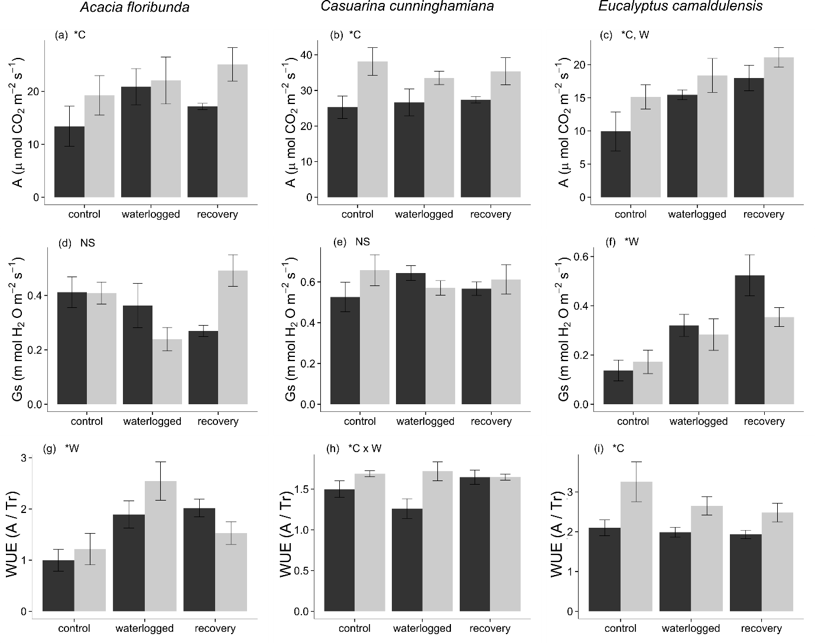

Figure . Gas exchange measurements under each combination of waterlogging and CO2 level treatments. Tr = transpiration rate (mmol H20 m-2 s-1) Dark shaded columns represent measurements under ambient atmospheric CO2 concentration (390 ppm), light shaded columns represent measurements under elevated atmospheric CO2 concentration (550 ppm). Error bars represent the standardised mean error. * - letters denote statistical significance of differences between treatment combinations (NS = no significant difference, C = significant difference between CO2 level treatments, W = significant difference between waterlogging treatments).

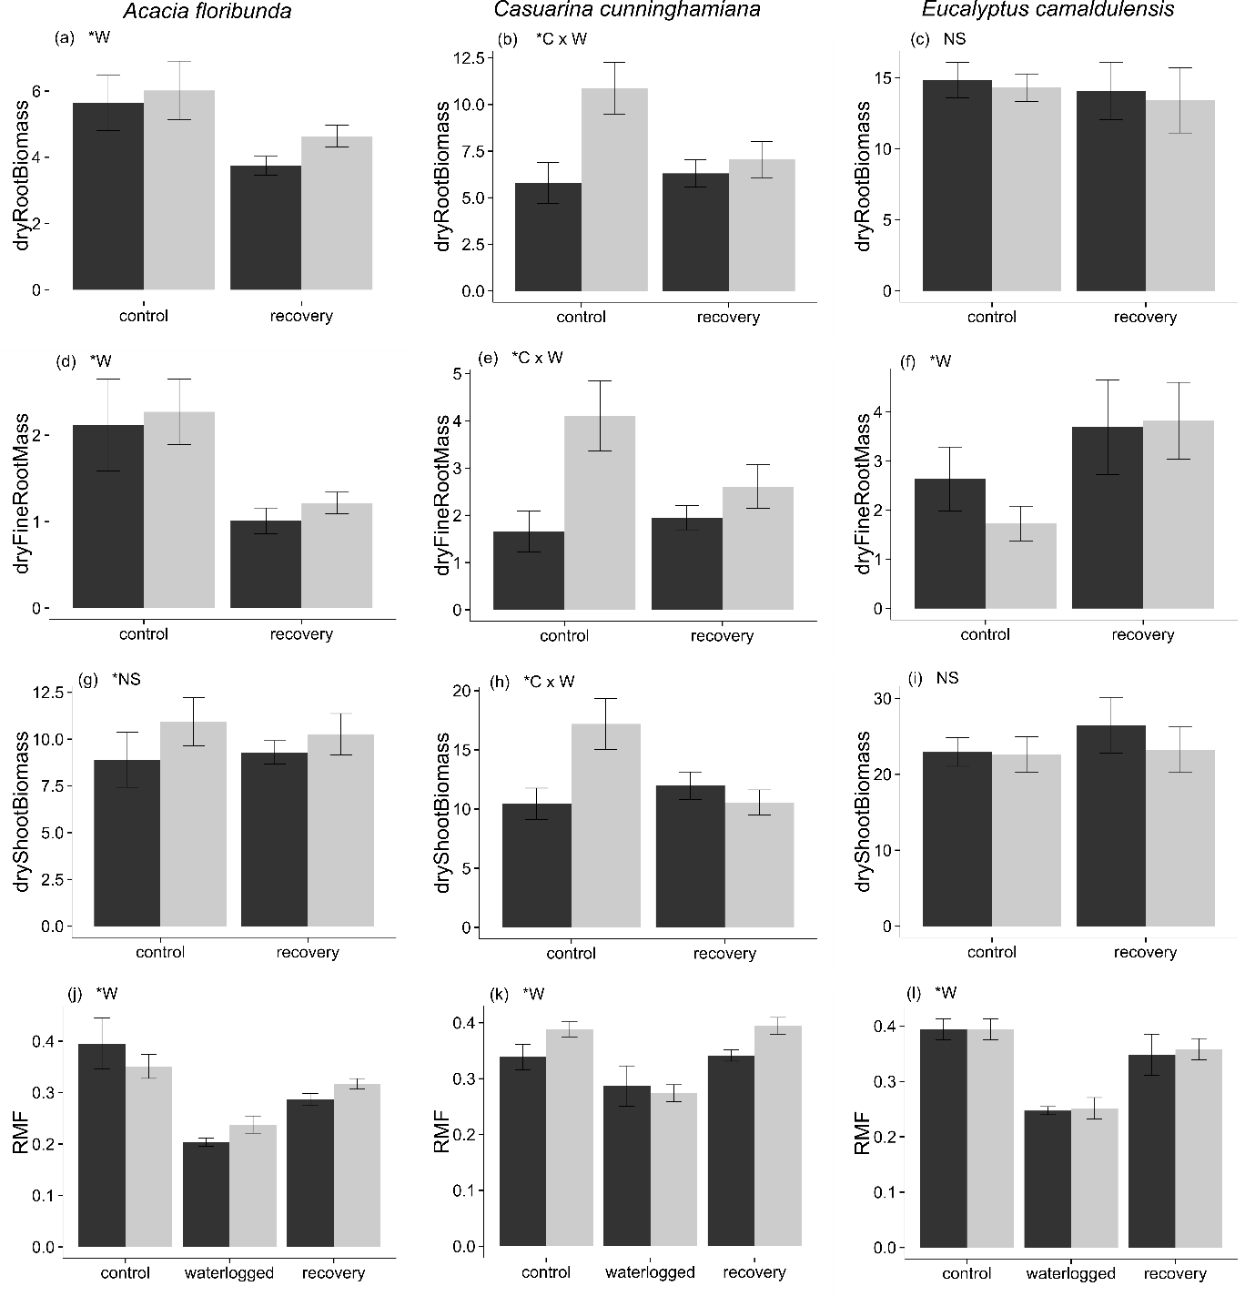

Figure 2. Biomass and root mass fraction (RMF) measurements under each combination of waterlogging and CO2 level treatments. Dark shaded columns represent measurements under ambient CO2 concentration (390 ppm), light shaded columns represent measurements under elevated CO2 concentration (550 ppm). Error bars represent the standardised mean error. * - letters denote statistical significance of differences between treatment combinations (NS = no significant difference, C = significant difference between CO2 level treatments, W = significant difference between waterlogging treatments).

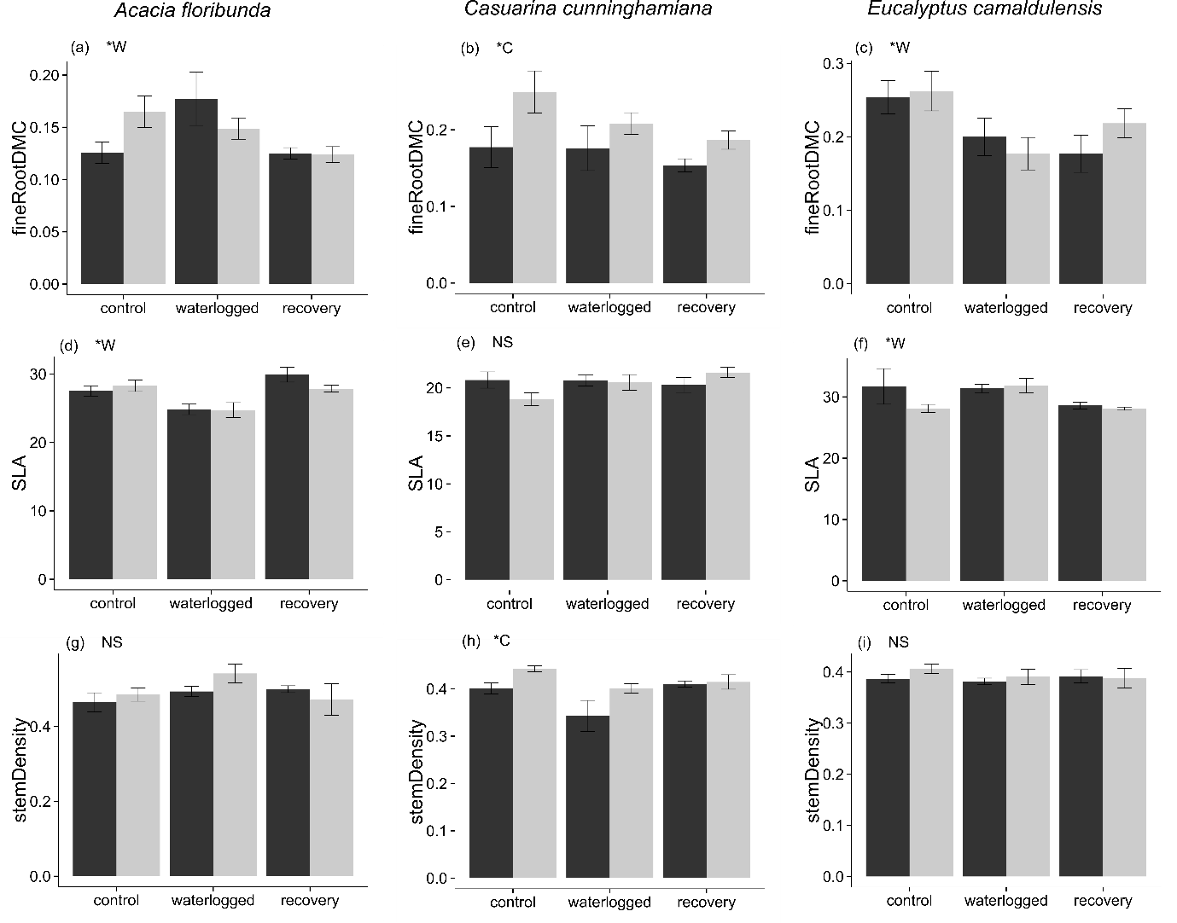

Figure 3. Functional trait measurements under each combination of waterlogging and CO2 level treatments. Dark shaded columns represent measurements under ambient CO2 concentration (390 ppm), light shaded columns represent measurements under elevated CO2 concentration (550 ppm). Error bars represent the standardised mean error. * - letters denote statistical significance of differences between treatment combinations (NS = no significant difference, C = significant difference between CO2 level treatments, W = significant difference between waterlogging treatments).